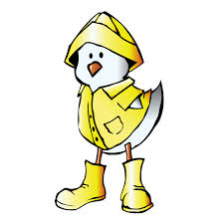Spring is here! Haven’t you heard the new? The weather is warming up and the snow is melting quickly. We are now officially between winter boots and rubber boots. Yeah! This is the time of the year when kids want to take it all off but we say…. “Not so quick!” If your child wears rubber boots at school, make sure he or she is wearing warm socks. There is still plenty of snow around so, wearing rubber boots means cold toes. The snow pants are losing their appeal fast! A lighter pair of pants would do. We can let the scarves at home but the gloves and the hat will stay for a little longer. You might want to have you child wear a spring coat but remember that it has to be warm enough for this time of the year. Winter clothing will eventually disappear but for now … you can be the judge. Make sure your child make a slow transition between the seasons.

Thanks
Gaëtane McGraw

