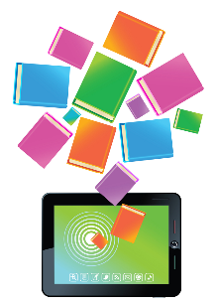
Interested in a source of 9,000 FREE eBooks and audiobooks?
Which is open 24/7 and accessible from school or home….
Check out SORA!

SORA is a provincial eLibrary created by the Department of Education and Early Childhood Development which provides students, parents (via their child’s school username and password), and staff in Anglophone schools with access to a wide range of eBooks, audiobooks, and read-alongs, which will appeal to a variety of student interests and reading levels.
The collection includes a mix of fiction, nonfiction, French language books, and culturally- inclusive books, including those with Indigenous content. Books are also chosen to ensure a range of representation for inclusive environments: LGBTQ2SI, neurodiversity, and family context.
Books can be checked in and out-- both inside and outside of school--on school devices as well as personal devices.
For more information and step-by-step directions for accessing SORA, please read these attachments:
- SORA: NB School eLibrary Overview (infographic)
- Sign In to SORA (step-by-step guide)
For more information, talk to your child’s homeroom teacher or the school’s library worker.

