The Student Council would like to first say thank you to all who came and enjoyed the after school holiday festivities last week. Pictures will be posted on website so go check them out! http://tabusintacschool.nbed.nb.ca

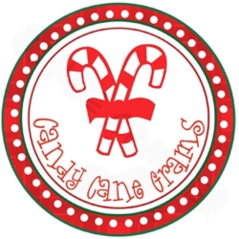Let’s Spread some Christmas Cheer!!

We will begin taking orders for Candy Grams! If you wish to purchase some Candy Grams, simply send in your money along with a note stating who they are for. The student council will write them up and deliver your special treats next week. Each candy gram costs 0.50 cents.

Speaking of Holiday Cheer…
We will kick of the countdown to Christmas vacation with Christmas Spirit Week!! Dec. 18th ⁻22nd

Monday | Tuesday | Wednesday | Thursday | Friday
PLAID DAY  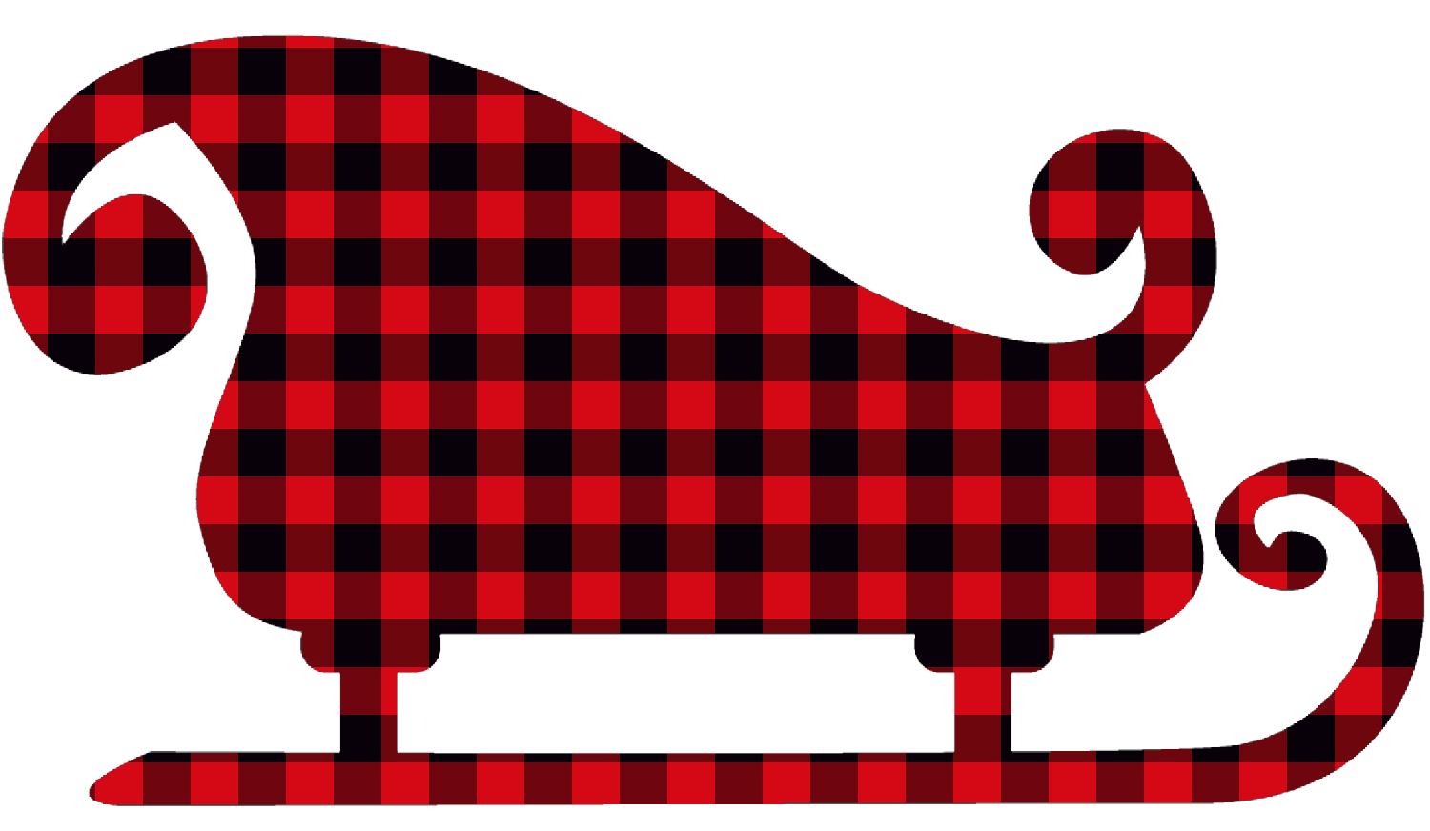 | Xmas Hat Day | Ugly Xmas Sweater Day  -or-  Xmas Socks Day  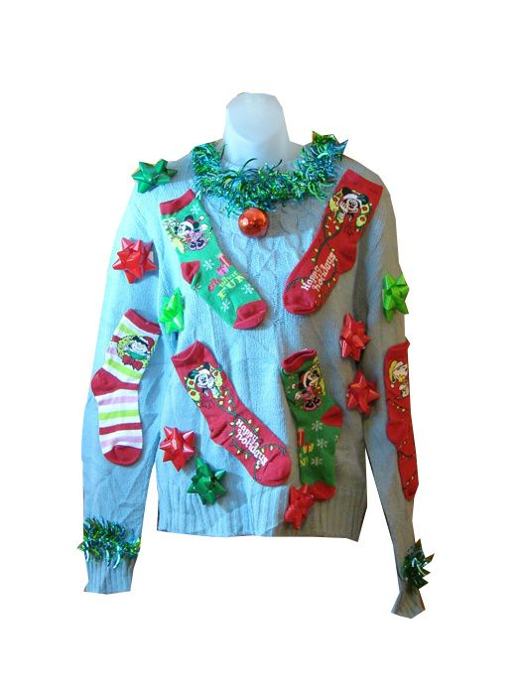 | Red & Green Day  -or-  Silver & Gold  Day  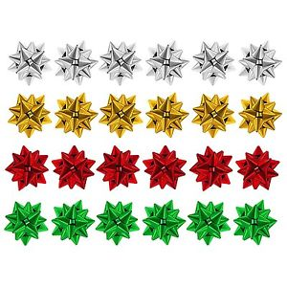 | Pajama Day

